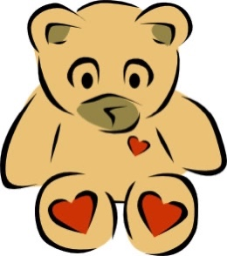
G1 Bee Class Newsletter
December 2024

Dear Parents,
Welcome to the Marshall ESL program. The Marshall ESL program continues our school’s education philosophy, Reading is the Way to Grow, from our kindergarten curriculum. The McGraw Hill Reading wonders series will enhance us to reach the goal throughout the following years.

Reading
The theme in Unit 4 Week 5 is about working with animals. The main text tells us what a guide dog is, as well as the qualities needed for a puppy to become a guide dog. We will also be reading the story of Koko the gorilla in the anthology book and learn how a gorilla was able to communicate with human using sign language.

Presentation
The presentation topic this month is “Caring for Animals”. The teacher will use this opportunity to show how to take care of a pet of the kids’ choice.

Writing
In December, kids will be asked to write a letter to their grandparent. They can use this opportunity to express their gratitude, they will also get a chance to ask their grandparents for a Christmas present.

Grammar
Kids will be doing workbooks in the grammar class to practice drills that are not only grammar related, but also in phonics, spelling, and comprehension. Some interactive games on computer will also help kids learn grammar in a very natural way.

G1 Bee Class Newsletter
December 2024
親愛的家長們：
歡迎加入馬歇爾英語課程！馬歇爾英語課程延續了我們學校的教育理念——「閱讀是成長之道」，這也是我們幼兒園課程的一部分。使用 McGraw Hill 的《Reading Wonders》系列教材，將幫助我們在接下來的幾年內實現這一目標。
感謝您對孩子英語學習的支持！
Reading
第 4 單元第 5 週的主題是「與動物合作」。主要文本介紹了導盲犬是什麼，以及小狗成為導盲犬所需的特質。我們還將閱讀選集中的故事《Koko the Gorilla》，了解一隻大猩猩如何通過手語與人類進行交流。

Presentation
本月的展示主題是「照顧動物」。老師將利用這個機會展示如何照顧孩子們選擇的寵物，幫助他們學習相關知識。

Writing
在十二月，孩子們需要寫一封信給他們的祖父母。他們可以藉此機會表達感謝之情，同時也有機會向祖父母提出自己的聖誕禮物願望。

Grammar
孩子們在語法課上將使用練習冊，進行不僅與語法相關，還涵蓋自然拼讀、拼寫和理解能力的練習。一些互動式的電腦遊戲也將幫助孩子們以更加自然的方式學習語法。

感謝您的閱讀

